B.Tech Career Success Ready Reckoner
A quick-reference guide to essential digital tools, technical interview preparation and job search strategy

At a Glance
Area | What You Need to Master | Outcome
Digital tools | Canva resume, DigiLocker, Google Forms, PowerPoint | Professional documentation and presentation readiness
Technical interviews | DSA, DBMS, OOPs, OS, Networks, project deep dive | Confidence across all four recruitment stages
Job search | Portfolio, ATS-ready resume, outreach pipeline | Applications that get noticed and shortlisted

Part I: Essential Digital Tools

1. Resume Preparation in Canva
- Sign in to Canva.com with your personal or professional account.
- Select a template. Search "Resume" or "CV" and filter for clean, modern, single-column styles suited to engineering and IT.
- Add personal information: full name, phone, professional email, GitHub and LinkedIn URLs.
- Structure experience in reverse chronological order, using action verbs and quantifiable results.
- Export via Share > Download > PDF Print, keeping the output high-resolution with selectable text.
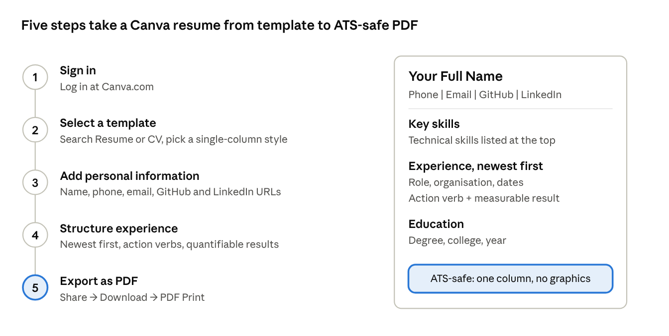
Canva resume · 5 steps with a sample ATS-safe layout
The sample page on the right shows the layout to aim for: one column, skills first, experience newest first. Reference: Canva resume maker.
ATS Tip: Avoid heavy graphics, multiple columns and visual skill bars if the resume will pass through an Applicant Tracking System. Simple typography ensures the text is parsed correctly.

2. DigiLocker Registration and Setup
- Access the DigiLocker app or digilocker.gov.in.
- Sign up with your legal name (as on Aadhaar), date of birth, mobile number and email, and set a 6-digit security PIN.
- Link Aadhaar using your 12-digit number and mobile OTP verification.
- Fetch documents through "Search Documents": marksheets, degree certificates, driving licence.
- Use the Drive section to store scanned copies of non-government credentials securely.
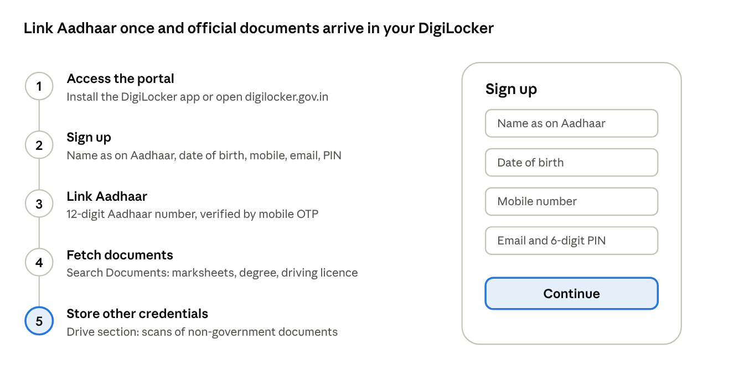
DigiLocker · 5 steps with a sample sign-up screen
The sample screen on the right is a schematic, not the live app. For real screenshots, see the government's DigiLocker User Manual; it is an older edition, so follow the PIN-based steps above.

3. Google Forms Setup and Deployment
- Initialize at forms.google.com with a blank form or a survey template.
- Title and instructions: use a concise, descriptive title and clear introductory guidance.
- Add questions with the (+) icon: Short Answer, Paragraph, Multiple Choice, Checkboxes or File Upload.
- Configure settings: mark critical fields "Required" and apply response validation for email formats or numeric limits.
- Distribute and analyze: share a short link or email, and link responses to a Google Sheet.
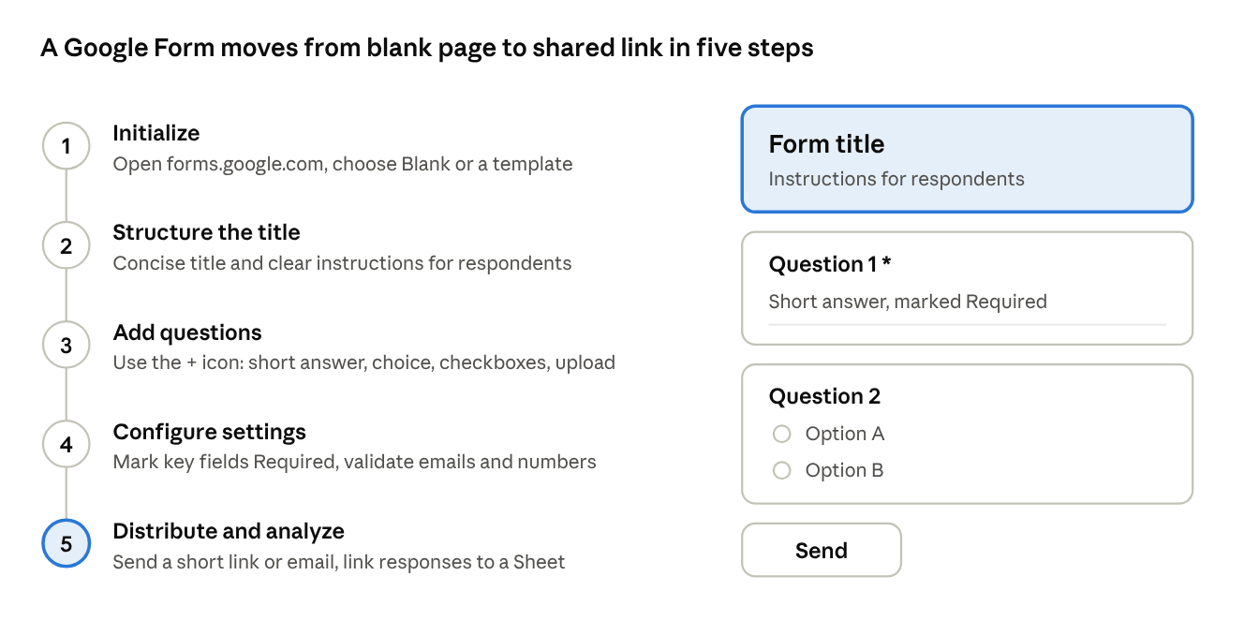
Google Forms · 5 steps with a sample form layout
The sample form on the right is a schematic of the layout you build in steps 2 to 4. Reference: Google's guide to creating your first form.

Part II: Technical Interview Preparation

Recruitment Stages
Stage | Focus Areas | Evaluation Criteria
1. Online Assessment | Quantitative aptitude, logical reasoning, verbal, core CS MCQs, 2 coding problems | Accuracy, time complexity, test case pass rate
2. Technical Round I | Data structures and algorithms, code writing, Big-O analysis | Problem-solving approach, clean logic, edge cases
3. Technical Round II | Core CS (DBMS, OOPs, OS, CN), final year project deep dive, system architecture | Depth of domain knowledge, hands-on project experience
4. HR and Managerial | Behavioural questions, cultural fit, communication, career aspirations, relocation | Soft skills, leadership, adaptability, stability

Core Technical Domains
Domain | Key Topics
Arrays and Strings | Two pointers, sliding window, prefix sums
Linear Structures | Linked lists, stacks, queues
Non-Linear Structures | Binary trees, BSTs, graphs (BFS/DFS)
Algorithms | Sorting, binary search, recursion, dynamic programming basics
DBMS and SQL | Joins, subqueries, indexing, normalization (1NF to 3NF), ACID properties
OOPs | Encapsulation, abstraction, inheritance, polymorphism (with live code examples)
OS and Networks | Deadlocks, threads, process synchronization, TCP/IP vs OSI layers, HTTP/HTTPS

How to Prepare for the Interview
Prepare stage by stage, matching your practice to what each round evaluates.
Stage | How to Prepare
1. Online Assessment | Practise aptitude, logical reasoning, verbal and core CS MCQs, plus 2 coding problems in timed mock tests. Focus on accuracy, time complexity and passing every test case.
2. Technical Round I | Drill the DSA topics above, write clean code, state the Big-O of each solution and check edge cases. Dry-run your code on paper or a whiteboard.
3. Technical Round II | Revise DBMS, OOPs, OS and Networks, backing OOPs concepts with live code examples. Review your final year project architecture end to end.
4. HR and Managerial | Prepare STAR answers for behavioural questions, and be ready to discuss career aspirations, relocation and teamwork.
Before every interview:
- Practise dry-running code on whiteboard or paper.
- Be able to explain your major project architecture end to end.
- Prepare 2-3 technical questions to ask the interviewer at the end.
- Rehearse project and behavioural answers in the STAR format (see Part III).
- Keep your resume, GitHub and LinkedIn consistent, since interviewers often start from them.

Detailed Preparation Guidelines

1. Understand the process first
- Find out which stages your target company uses: online assessment, two technical rounds, then HR.
- Read the job description and list the skills it names. Prepare those first.
- Note the evaluation criteria for each round (see the stages table above) and practise against them, not only for the right answer.

2. Data Structures and Algorithms (DSA)
- Learn in topic order: arrays and strings, then linked lists, stacks and queues, then trees and graphs, then sorting, binary search, recursion and basic dynamic programming.
- Master the patterns: two pointers, sliding window and prefix sums solve a large share of array and string problems.
- Solve, then review: after each problem, write down the pattern used, the time and space complexity, and the edge cases you missed.
- Explain aloud: state your approach before coding, as interviewers assess problem-solving approach and clean logic, not only the final code.
- Always check edge cases: empty input, a single element, duplicates, negative values and very large inputs.
- Code without an IDE: write solutions on paper or a whiteboard and dry-run them with a sample input.

3. Core CS subjects
Subject | What to revise | Practise explaining
DBMS and SQL | Joins, subqueries, indexing, normalization (1NF to 3NF), ACID properties | Why normalize? What does an index speed up? What does each ACID property guarantee?
OOPs | Encapsulation, abstraction, inheritance, polymorphism | Give a small live code example of each concept in the language you know best
Operating Systems | Deadlocks, threads, process synchronization | How does a deadlock occur and how can it be avoided? What is the difference between a process and a thread?
Computer Networks | TCP/IP vs OSI layers, HTTP and HTTPS | What happens when you type a URL in a browser? How does HTTPS differ from HTTP?
For each topic, aim to explain it in plain words in under a minute, then add one example. If you cannot, revise it again.

4. Your final year project
Technical Round II often goes deep on your project, so prepare it like a subject.
- Draw the architecture on paper and explain every component and how data moves between them.
- Be ready to justify each technology choice and name one alternative you rejected.
- Prepare the hardest problem you faced, what you tried, and how you fixed it (a ready-made STAR answer).
- Know your own code: expect questions on database design, algorithms used and what you would improve.
- Keep the GitHub repository clean, with a clear README and a working live demo.

5. Online assessment: aptitude, reasoning and verbal
- Practise quantitative aptitude, logical reasoning and verbal questions in timed sets, as speed matters as much as accuracy.
- Take full-length mock tests that include core CS MCQs and 2 coding problems, to build stamina.
- In coding problems, pass the sample cases first, then test your own edge cases before submitting.
- If you are stuck on one question, move on and return to it later.

6. HR and managerial round
- Prepare your story: a clear introduction covering your education, key projects, skills and what you want next.
- Use STAR: write two or three STAR answers (Situation, Task, Action, Result) for common themes such as teamwork, a challenge, a mistake and leadership. Include a measurable result wherever you can.
- Know your aspirations: be ready to explain your career goals, why this company and your view on relocation.
- Show soft skills: communicate clearly, listen fully before answering and stay calm when you do not know something.
- Ask questions: prepare 2-3 thoughtful questions about the team, the work and how new joiners learn.

7. Practise with mock interviews
- Ask a friend, senior or faculty member to interview you, or record yourself answering aloud.
- Practise coding on a shared document or paper with someone watching, as this is closest to the real round.
- Ask for feedback on clarity, structure and confidence, then fix one weakness at a time.
- Keep a short log of questions you could not answer and revise them before the next mock.

8. The day before and the day of the interview
- ☐ Re-read your resume and be ready to explain every line on it
- ☐ Revise your project architecture and your STAR answers
- ☐ Check your laptop, internet connection, camera and microphone for an online interview
- ☐ Keep copies of your resume and key documents ready, including those saved in DigiLocker
- ☐ Sleep well and arrive or log in early
- ☐ Think aloud, ask for clarification when a question is unclear, and stay calm if you get stuck

Sample Interview Questions for B.Tech CSE
Use these to test yourself. For each one, answer aloud in under two minutes, then add a short example or code snippet.

Data Structures and Algorithms
Topic | Sample questions
Arrays and Strings | Find two numbers in an array that add up to a target. Find the longest substring without repeating characters. Find the maximum sum of a subarray of size k.
Linked Lists, Stacks, Queues | Reverse a linked list. Detect a cycle in a linked list. Check for balanced brackets using a stack. Implement a queue using two stacks.
Trees and Graphs | Traverse a binary tree in order, pre order and level order. Check whether a binary tree is a BST. Explain BFS and DFS and when to use each.
Algorithms | Explain binary search and its complexity. Compare quick sort and merge sort. Solve a basic dynamic programming problem such as Fibonacci or the coin change problem.
Complexity | What are the time and space complexity of your solution? Can you improve it?

DBMS and SQL
- What is normalization? Explain 1NF, 2NF and 3NF with an example.
- What are the ACID properties? Why are they important in transactions?
- What is the difference between INNER JOIN, LEFT JOIN and RIGHT JOIN?
- What is an index, and when can it slow things down?
- Write a query to find the second highest salary in a table.
- What is the difference between a primary key and a unique key?

Object-Oriented Programming
- Explain encapsulation, abstraction, inheritance and polymorphism with a real-life example each.
- What is the difference between method overloading and method overriding?
- What is the difference between an abstract class and an interface?
- Can you show runtime polymorphism in code?

Operating Systems
- What is the difference between a process and a thread?
- What is a deadlock? List the conditions that cause it and one way to prevent it.
- What is process synchronization, and why are semaphores or mutexes used?
- What is the difference between paging and segmentation?

Computer Networks
- Compare the TCP/IP model and the OSI model.
- What is the difference between TCP and UDP?
- What happens when you type a URL in a browser and press Enter?
- What is the difference between HTTP and HTTPS?

Project and HR
- Walk me through your final year project architecture.
- Why did you choose this technology stack, and what alternatives did you consider?
- Describe the toughest bug you fixed, using the STAR method.
- Tell me about yourself. Where do you see yourself in a few years? Are you open to relocation?
Tip: Keep a notebook of every question you could not answer. Revise it before each mock interview.

Model Answers for B.Tech CSE
Use these as a guide to structure and depth. Always put the answer in your own words and add an example.

1. Data Structures and Algorithms: approach and complexity
Question | Model approach | Complexity
Two numbers that add up to a target | Scan the array once, storing each value in a hash map. For each element, check whether target minus the element is already in the map. | O(n) time, O(n) space
Longest substring without repeating characters | Sliding window with a set or map. Expand the right end; when a repeat appears, move the left end forward until the window is valid. Track the maximum length. | O(n) time
Maximum sum of a subarray of size k | Sum the first k elements, then slide the window by adding the new element and removing the oldest. | O(n) time, O(1) space
Reverse a linked list | Walk the list with three pointers (previous, current, next), reversing each link as you go. | O(n) time, O(1) space
Detect a cycle in a linked list | Floyd's method: a slow pointer moves one step, a fast pointer moves two. If they meet, a cycle exists. | O(n) time, O(1) space
Balanced brackets | Push each opening bracket on a stack. On a closing bracket, pop and check that it matches. The string is balanced if the stack is empty at the end. | O(n) time
Queue using two stacks | Push into an input stack. For a dequeue, if the output stack is empty, move everything from the input stack to it, then pop. | Amortized O(1) per operation
Tree traversals | In order: left, node, right. Pre order: node, left, right. Level order: use a queue, visiting level by level. | O(n) time
Is a binary tree a BST? | Check that every node lies within a valid range, or check that the in-order traversal is strictly increasing. | O(n) time
BFS vs DFS | BFS uses a queue and explores level by level, so it finds the shortest path in an unweighted graph. DFS uses a stack or recursion and goes deep first, so it suits path exploration and cycle detection. | O(V + E) time for both
Binary search | On a sorted array, compare with the middle element and discard half the range each step. | O(log n) time
Quick sort vs merge sort | Quick sort partitions around a pivot, works in place, but has a worst case of O(n squared). Merge sort always takes O(n log n), is stable, but needs extra space. | See the description
Dynamic programming (Fibonacci, coin change) | Define the subproblem, write the recurrence, then store results (memoization or a table) so each subproblem is solved once. | Depends on the problem
Always close by stating the time and space complexity, and mention one way to optimize if time allows.

2. DBMS and SQL: model answers
- Normalization: organising data to reduce redundancy and update anomalies. 1NF: each field holds a single atomic value. 2NF: 1NF plus no partial dependency on part of a composite key. 3NF: 2NF plus no transitive dependency, so non-key columns depend only on the key.
- ACID: Atomicity (a transaction completes fully or not at all), Consistency (the database moves from one valid state to another), Isolation (concurrent transactions do not interfere), Durability (committed data survives a failure). A bank transfer is a good example.
- Joins: INNER JOIN returns only matching rows from both tables. LEFT JOIN returns all rows from the left table plus matches from the right, with NULLs where there is no match. RIGHT JOIN is the reverse.
- Index: a structure that speeds up searches on a column. It can slow down inserts, updates and deletes, and uses extra storage, so index only the columns you search often.
- Second highest salary: SELECT MAX(salary) FROM employees WHERE salary < (SELECT MAX(salary) FROM employees);
- Primary key vs unique key: both enforce uniqueness. A table has only one primary key and it cannot be NULL. A table can have several unique keys, and a unique key may allow a NULL depending on the database.

3. Operating Systems: model answers
- Process vs thread: a process is a program in execution with its own memory space. A thread is a lightweight unit of execution inside a process, and threads of the same process share its memory, so switching between them is cheaper.
- Deadlock: a state where processes wait forever for resources held by each other. It needs four conditions together: mutual exclusion, hold and wait, no preemption and circular wait. Preventing any one of them avoids deadlock, for example by requesting all resources at once or ordering resource requests.
- Process synchronization: coordinating processes or threads that share data so that the result is correct. Semaphores and mutexes ensure that only one thread enters a critical section at a time, which prevents race conditions.
- Paging vs segmentation: paging divides memory into fixed-size pages and avoids external fragmentation. Segmentation divides memory into variable-size logical segments, such as code, data and stack, and matches how programmers see a program.

4. Computer Networks: model answers
- TCP/IP vs OSI: OSI is a seven-layer reference model. TCP/IP is a practical model with fewer layers (commonly four) that the internet actually uses. Be ready to name the layers and give one protocol for each.
- TCP vs UDP: TCP is connection-oriented and reliable, with ordering and retransmission, and suits web pages and file transfer. UDP is connectionless and faster with no delivery guarantee, and suits streaming and gaming.
- What happens when you type a URL: the browser checks its cache, then DNS resolves the domain name to an IP address. A TCP connection is opened (with a TLS handshake for HTTPS), the browser sends an HTTP request, the server responds, and the browser renders the page.
- HTTP vs HTTPS: HTTPS is HTTP over TLS. It encrypts the data in transit, authenticates the server and protects against eavesdropping and tampering.

5. Project and HR: how to answer
Question | How to answer
Walk me through your project architecture | Start with the problem and users, then give the main components in order (front end, back end, database, external services), and explain how data flows between them. Finish with what you would improve.
Why this technology stack? | Name the requirement, the choice you made, why it fit, and one alternative you rejected with a reason.
Describe the toughest bug you fixed | Use STAR. Situation: what broke. Task: your responsibility. Action: how you investigated and fixed it. Result: what improved and what you learned.
Tell me about yourself | Give a 60 to 90 second summary: your education, key projects and skills, then why you want this role. Keep it relevant and avoid reading your resume aloud.
Where do you see yourself in a few years? | Show a growth plan linked to the role: deepening technical skills and taking on more responsibility. Be honest and avoid vague answers.
Are you open to relocation? | Answer honestly. If you are flexible, say so and why. If you have a constraint, state it politely and calmly.
Remember: a correct answer delivered clearly, with an example and its trade-offs, scores higher than a memorized definition.

Part III: Job Search Strategy and Execution

Phase 1: Portfolio and Application Preparation
- Single-page resume: ATS-friendly formatting, with key technical skills at the top.
- GitHub repository: production-ready code, clear README documentation and working live demos.
- LinkedIn profile: a clean headline (for example, "B.Tech CSE '26 | Java & DSA Specialist") and concise project summaries.

Phase 2: Outreach and Application Pipeline
- Campus placements: prioritize college drives and practise timed mock coding tests.
- Off-campus portals: keep active profiles on LinkedIn Jobs, Naukri and Wellfound (for high-growth startups).
- Employee referrals: contact company alumni with a brief note and relevant project links.

Structured Answers: The STAR Method
Component | How to Apply It
S: Situation | Briefly describe the context, project constraints or system issue
T: Task | State your specific responsibility or the goal to be achieved
A: Action | Detail the exact steps, algorithm, technology stack or leadership actions you took
R: Result | Highlight quantifiable metrics, performance gains, test outcomes or key takeaways

Final Preparation Checklist
- ☐ Resume is single-page, ATS-friendly and exported as PDF
- ☐ DigiLocker is set up with marksheets and degree certificates
- ☐ GitHub has clean READMEs and live demos
- ☐ LinkedIn headline and project summaries are updated
- ☐ Code dry-run practised on paper or whiteboard
- ☐ 2-3 questions prepared to ask the interviewer
- ☐ Final year project architecture reviewed end to end

